# Spring Tutorial 01 - Introduction to Spring Framework

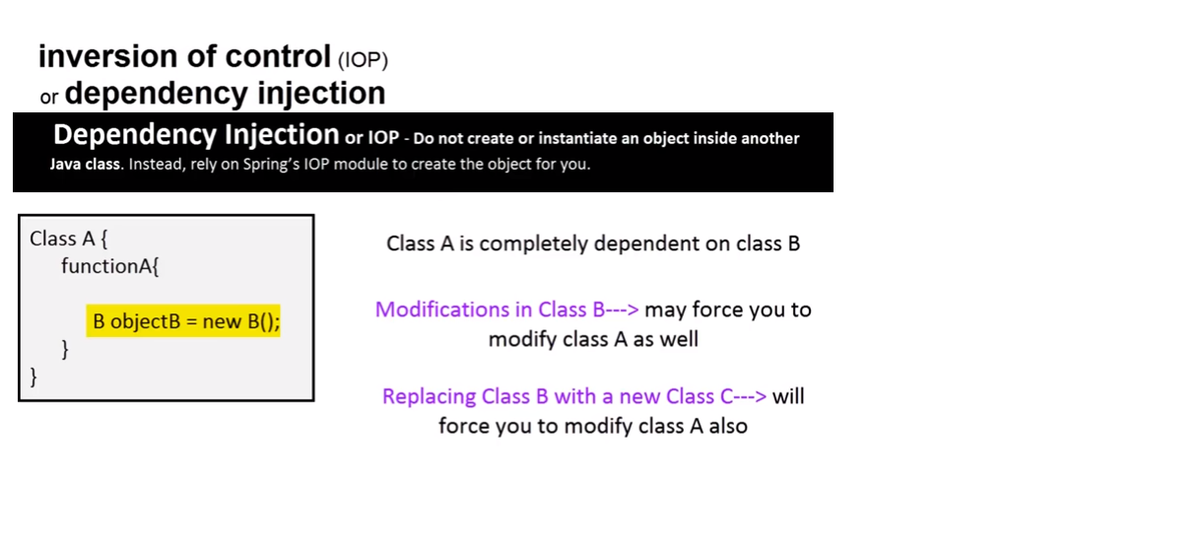

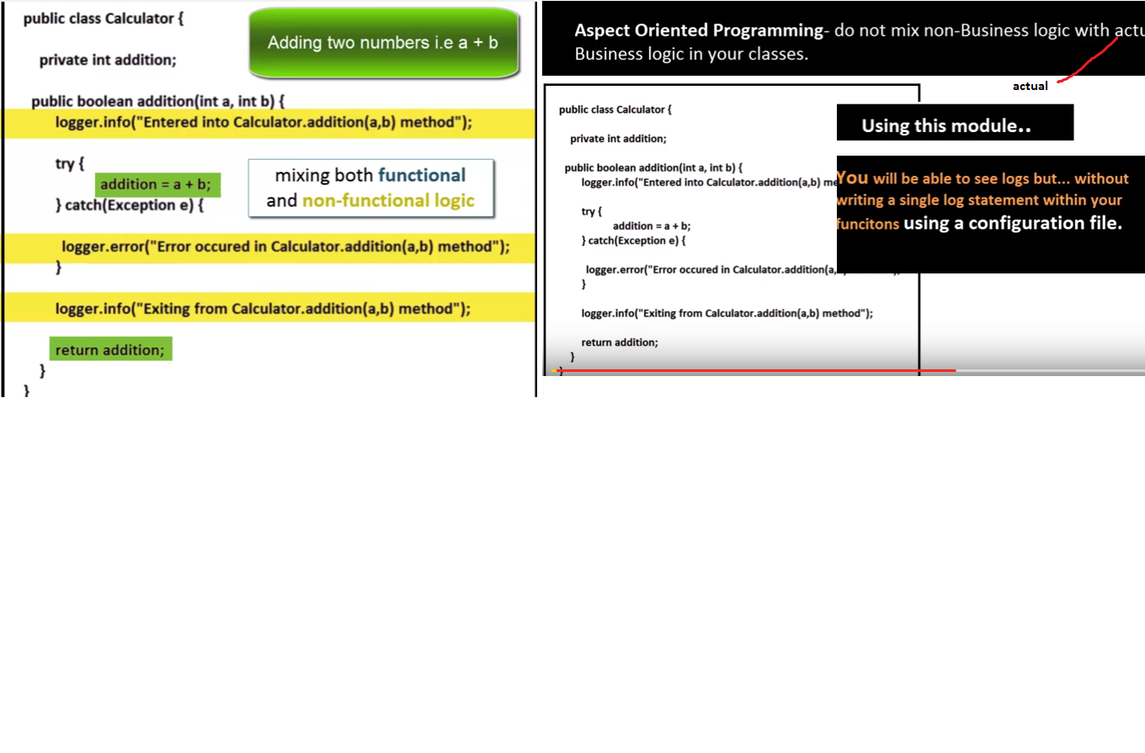

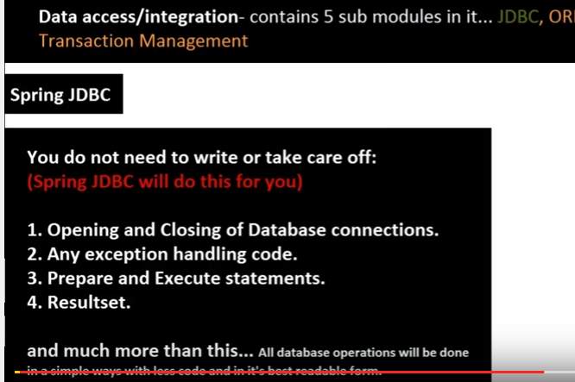

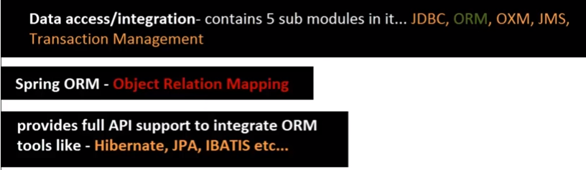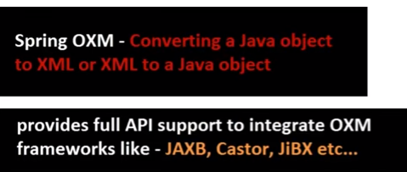

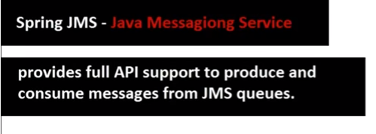

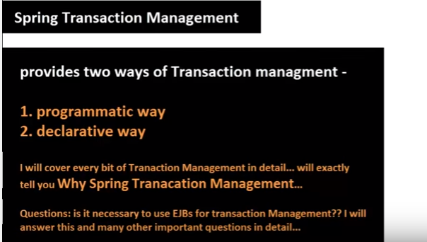

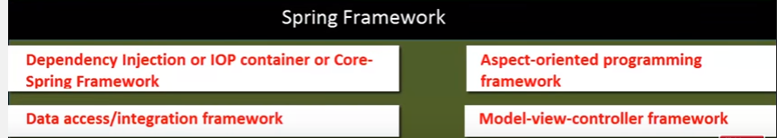



Advanced Features in Spring: Both Web and non-web application

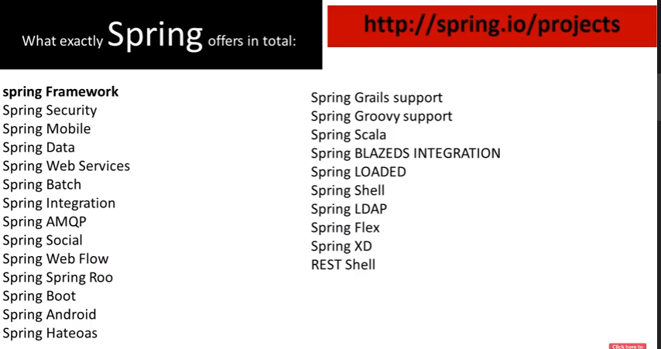

# Spring Tutorial 02 - Understanding Dependency Injection 01 ( problems if you do not use it )

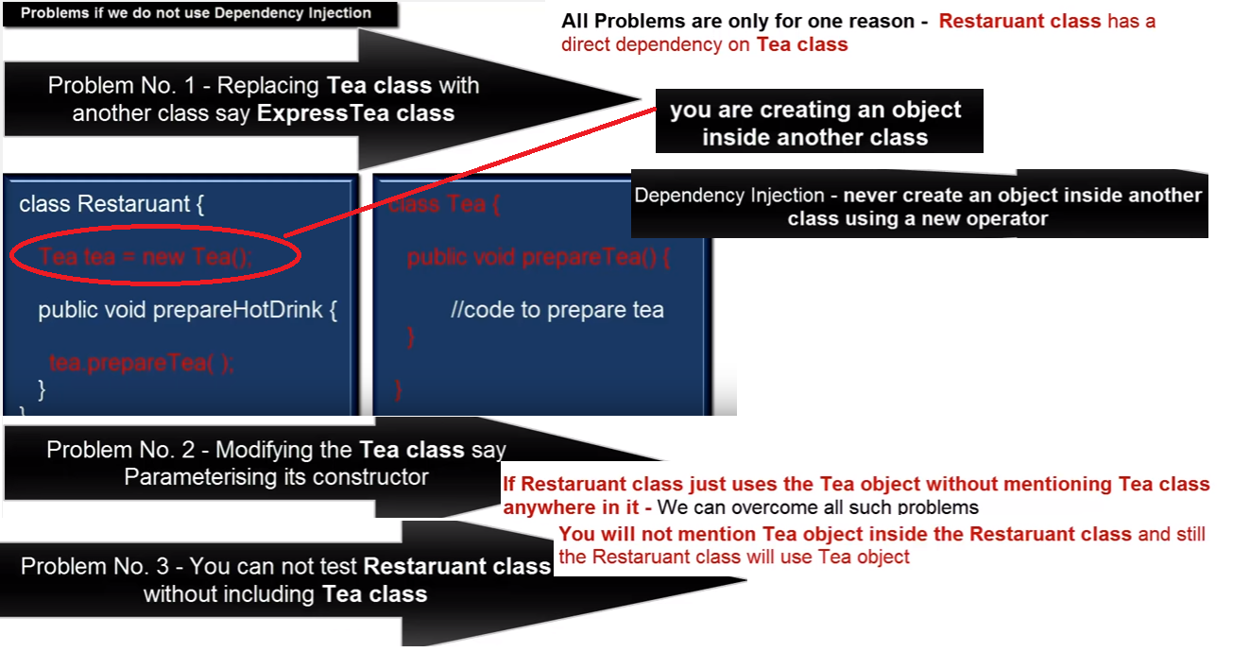

# Spring Tutorial 03 - Understanding Dependency Injection 02 ( Concept Explanation )

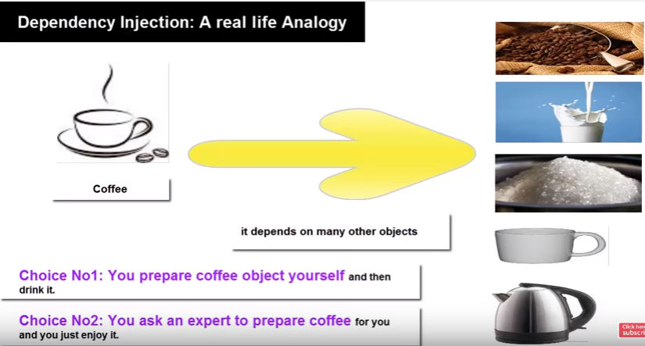

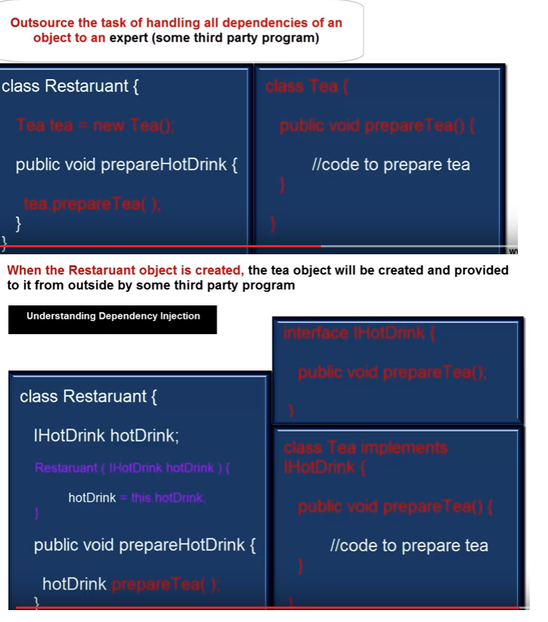

# Spring Tutorial 04 - Installation and setup (Hands on using Eclipse IDE)



Maven or Gradel



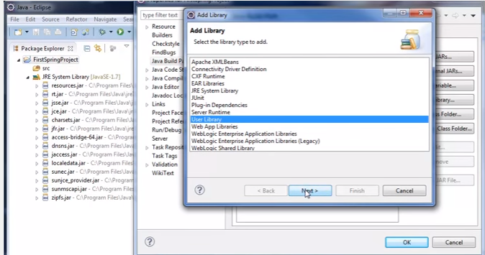



# Spring Tutorial 05 - creating first Spring application

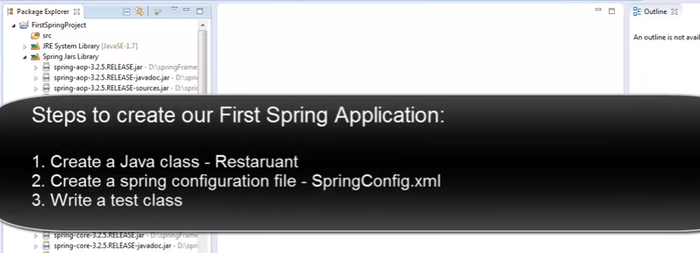

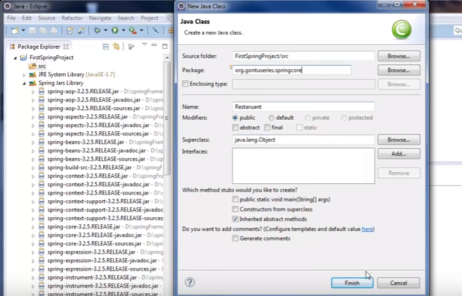

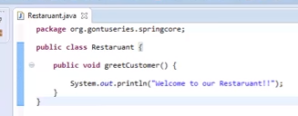

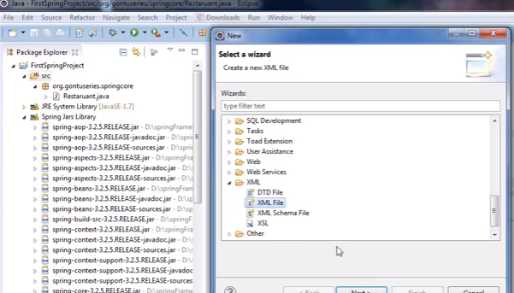

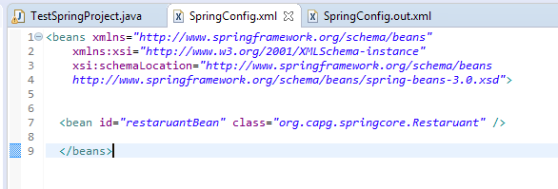

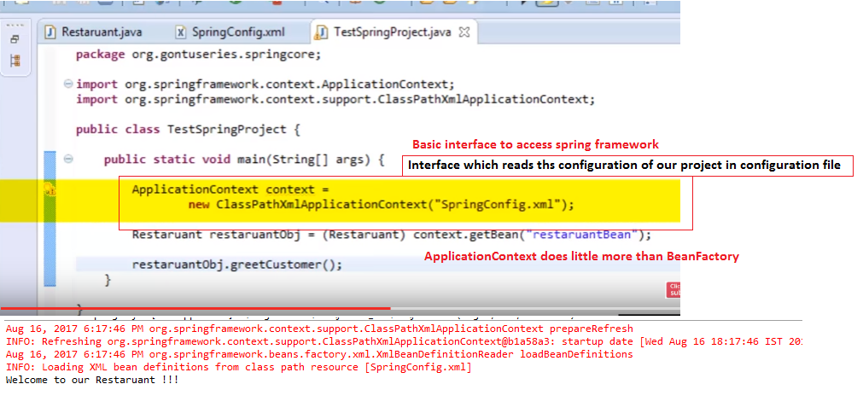

# Spring Tutorial 06 - Injecting value into a Bean property

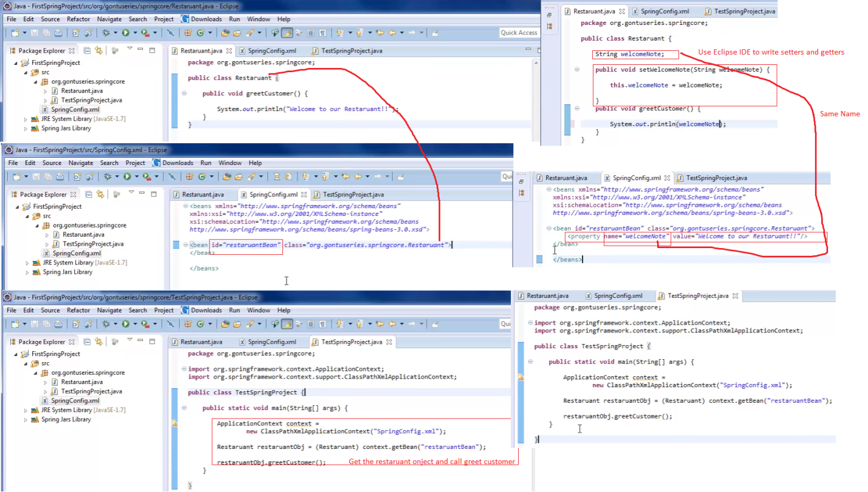

# Spring Tutorial 07 - Dependency Injection using constructor way ( Hands on using Eclipse IDE )

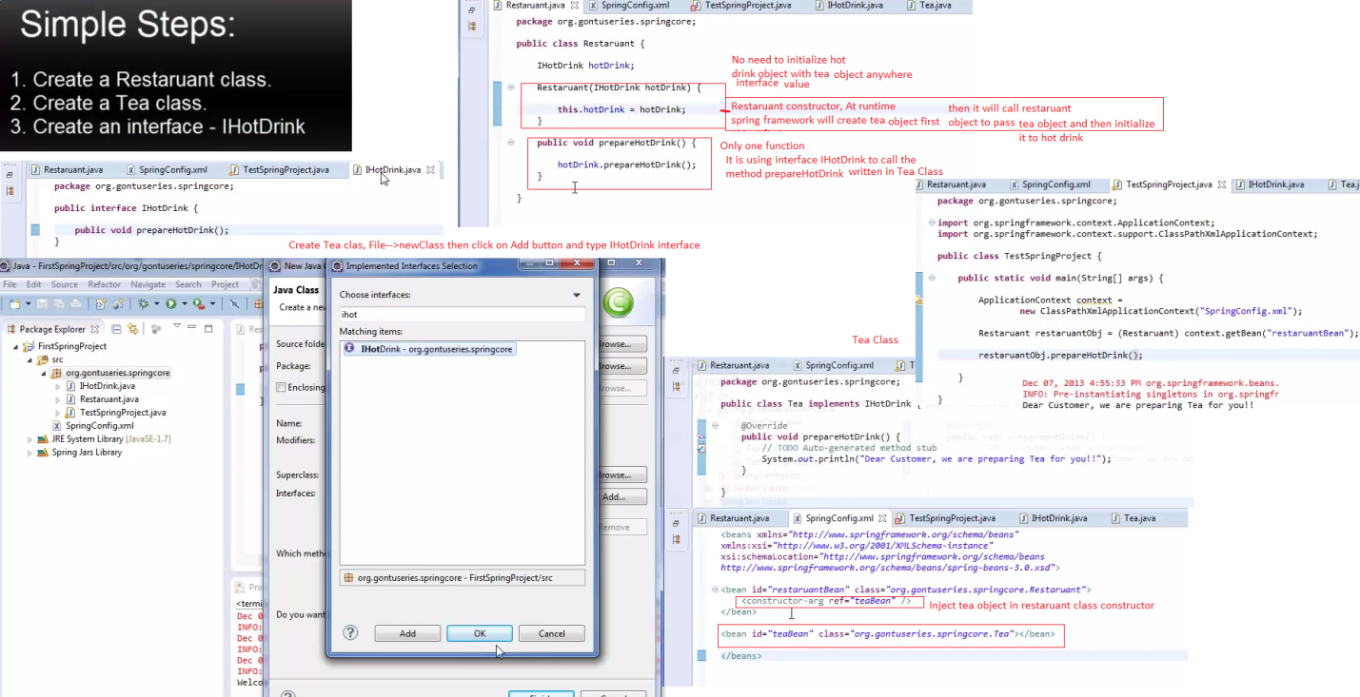

# Spring Tutorial 8 - Dependency Injection using setter method way ( Hands on using Eclipse IDE )

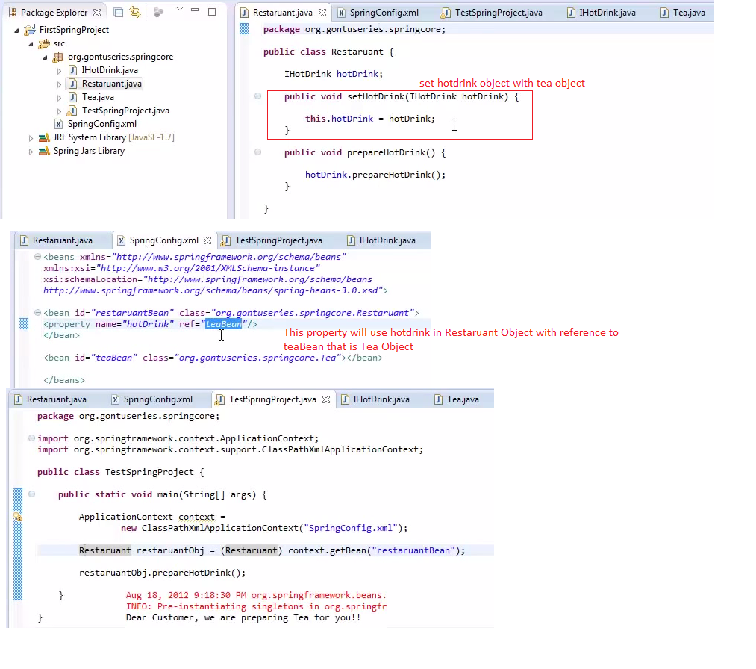

# Spring Tutorial 9 - Dependency Injection with a Collection property ( Hands on using Eclipse IDE )

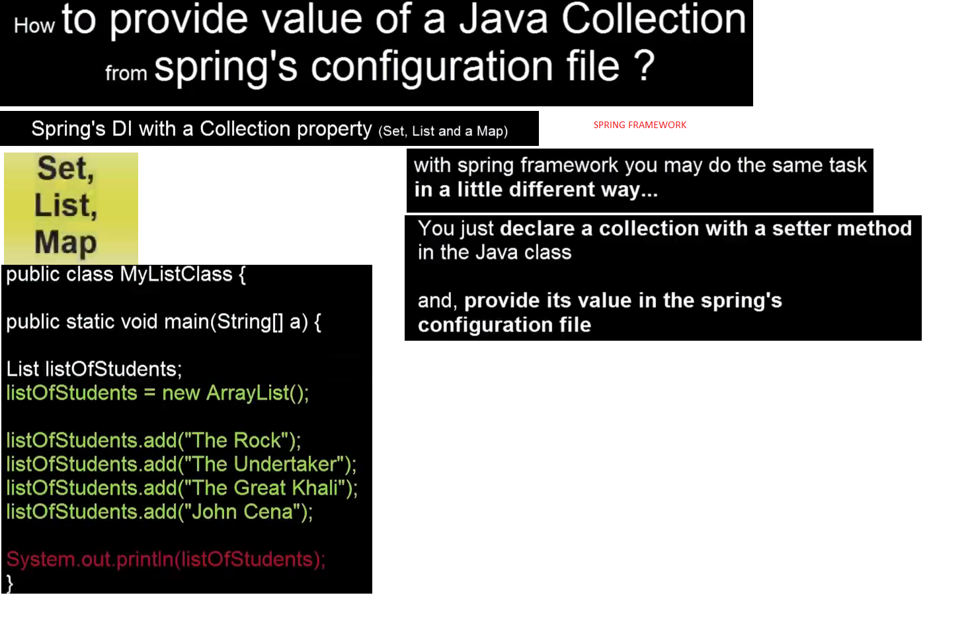

Print all waiters name in the console

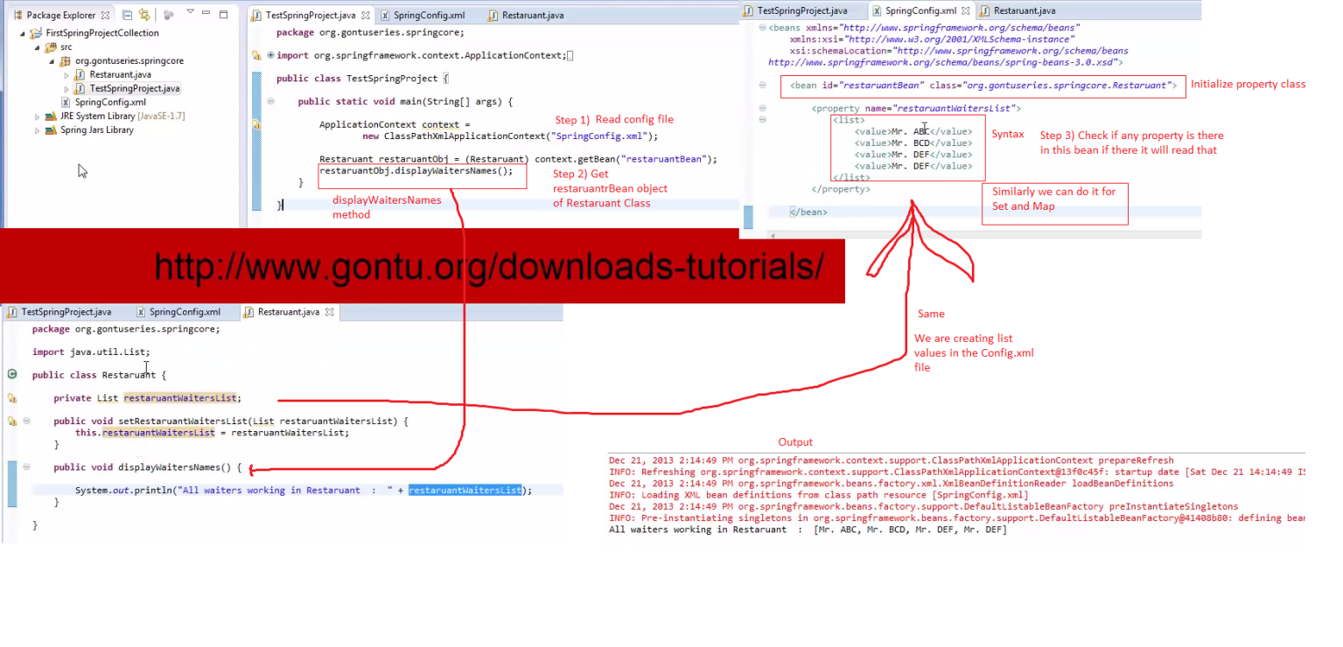

# Spring Tutorial 10 - Bean Scope (concept and hands on using Eclipse IDE)

# 

# Spring Tutorial 11 - Lazy loading and Pre-loading of a Bean

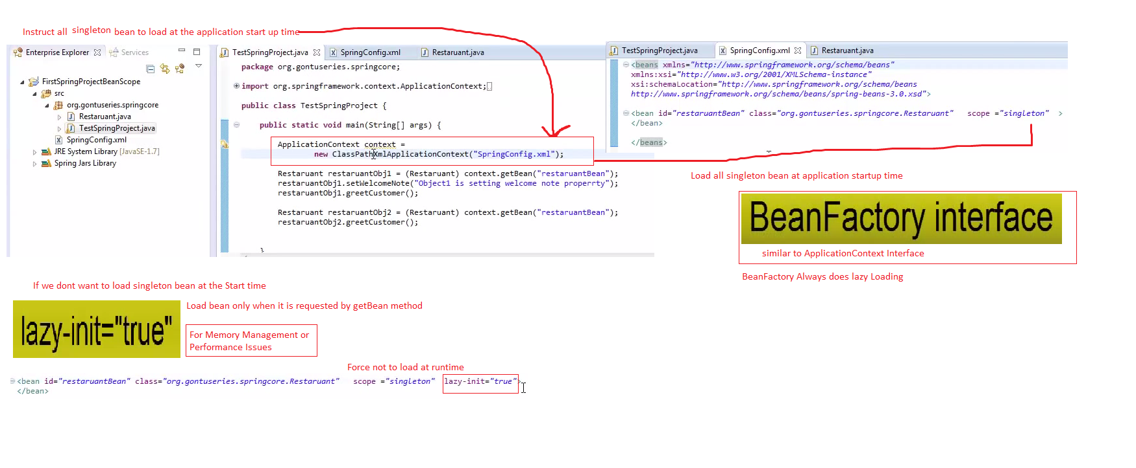

# Spring Tutorial 12 - Bean Life Cycle – Recommended Way

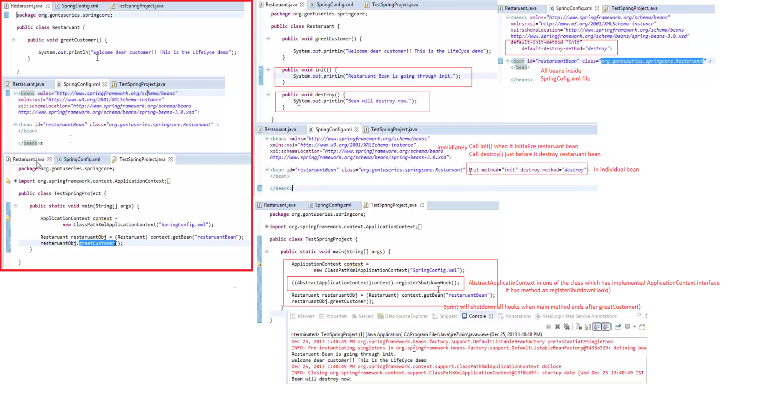

# Spring Tutorial 13 - Bean Life Cycle using Annotations and InitializingBean,DisposableBean interface

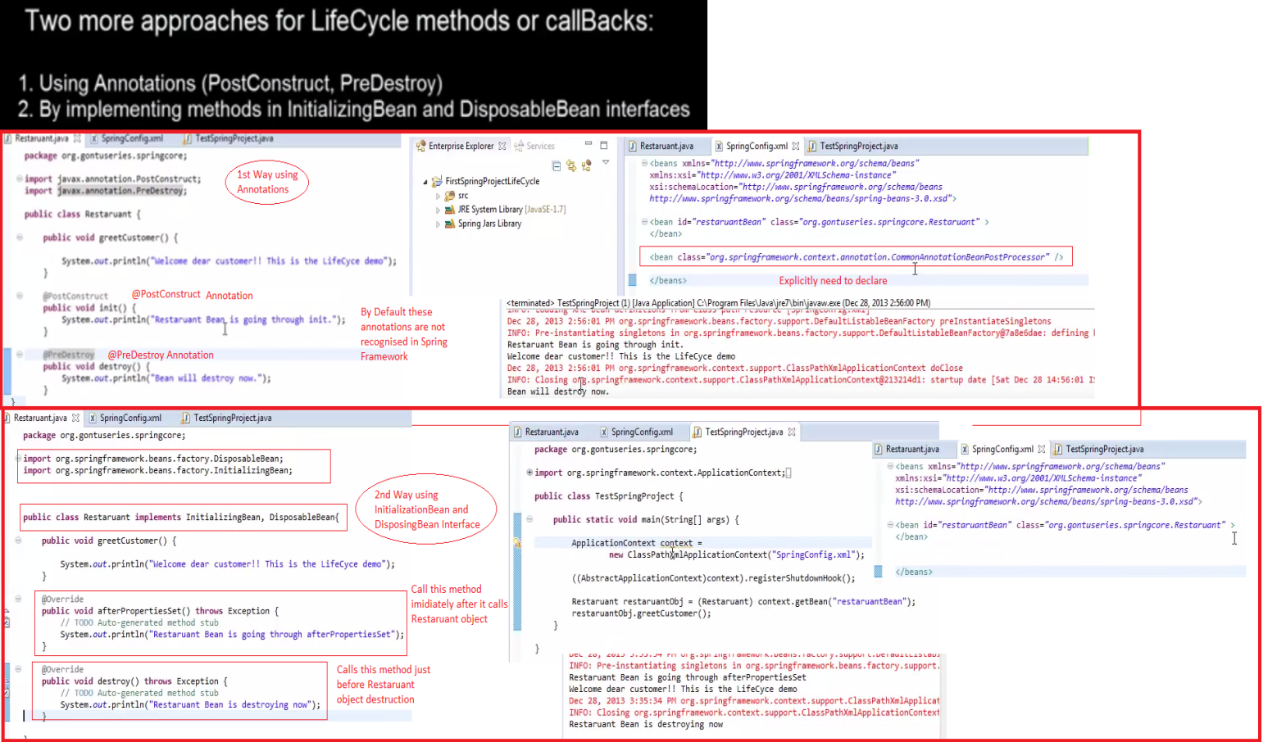

# Spring Tutorial 14 - A BeanPostProcessor concept in spring (with hands on using Eclipse)

**BeanPostProcessor** - A class which allows you to modify a beans instance or perform any tasks once it is created or initialized by spring container.

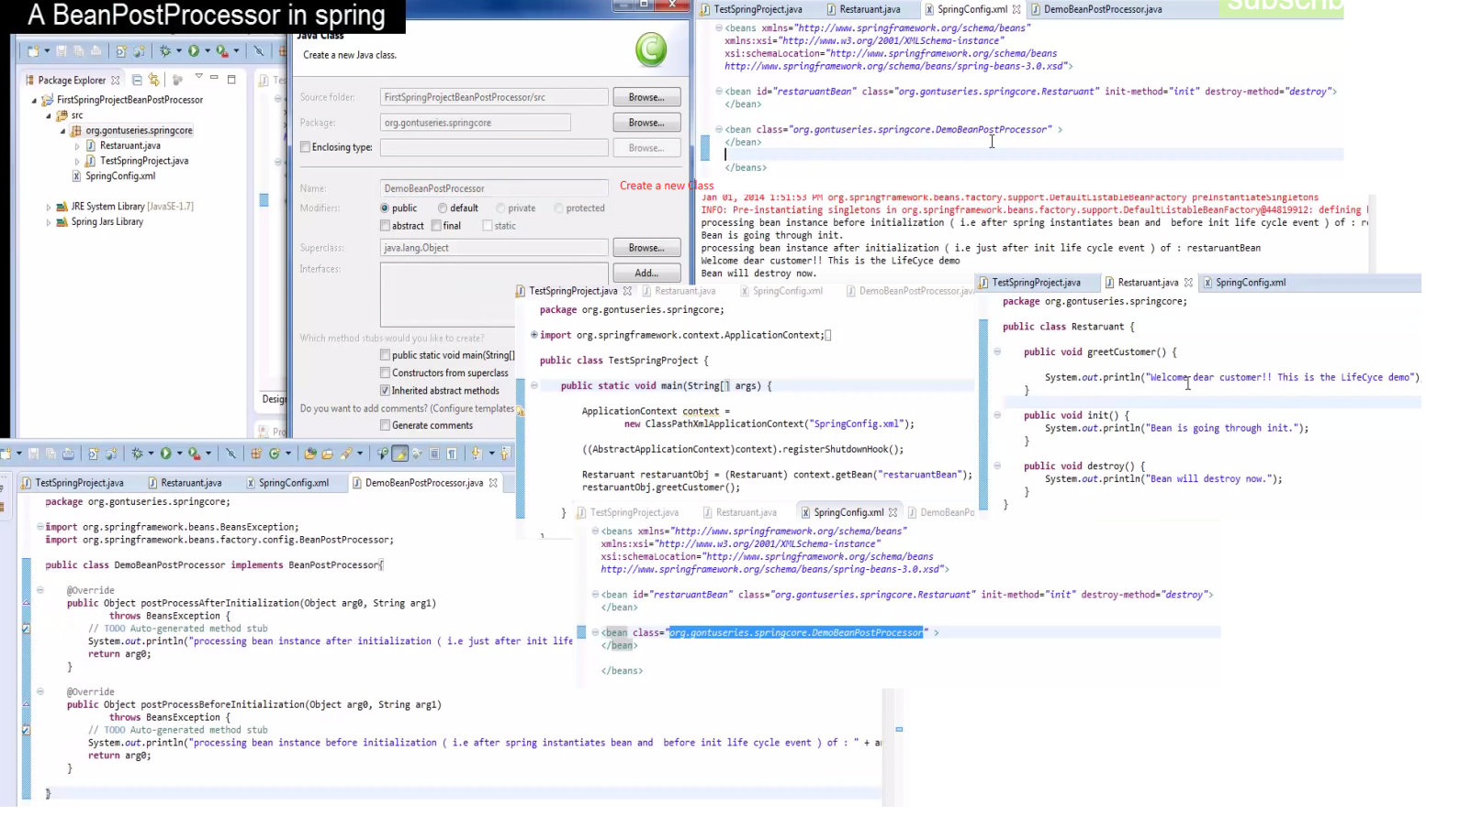

# Spring Tutorial 15 - Implementing an Ordered interface in a BeanPostProcessor class

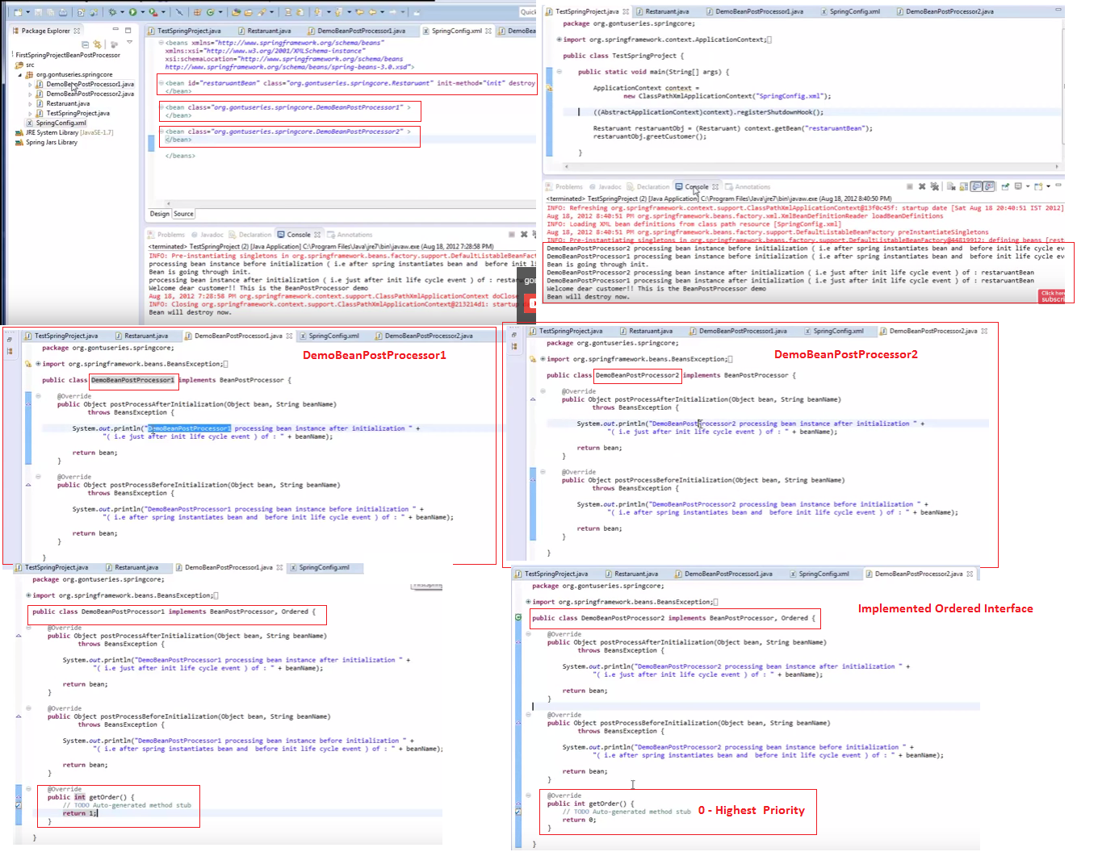

# Spring Tutorial 16 - A BeanFactoryPostProcessor concept in spring ( with hands on using Eclipse )

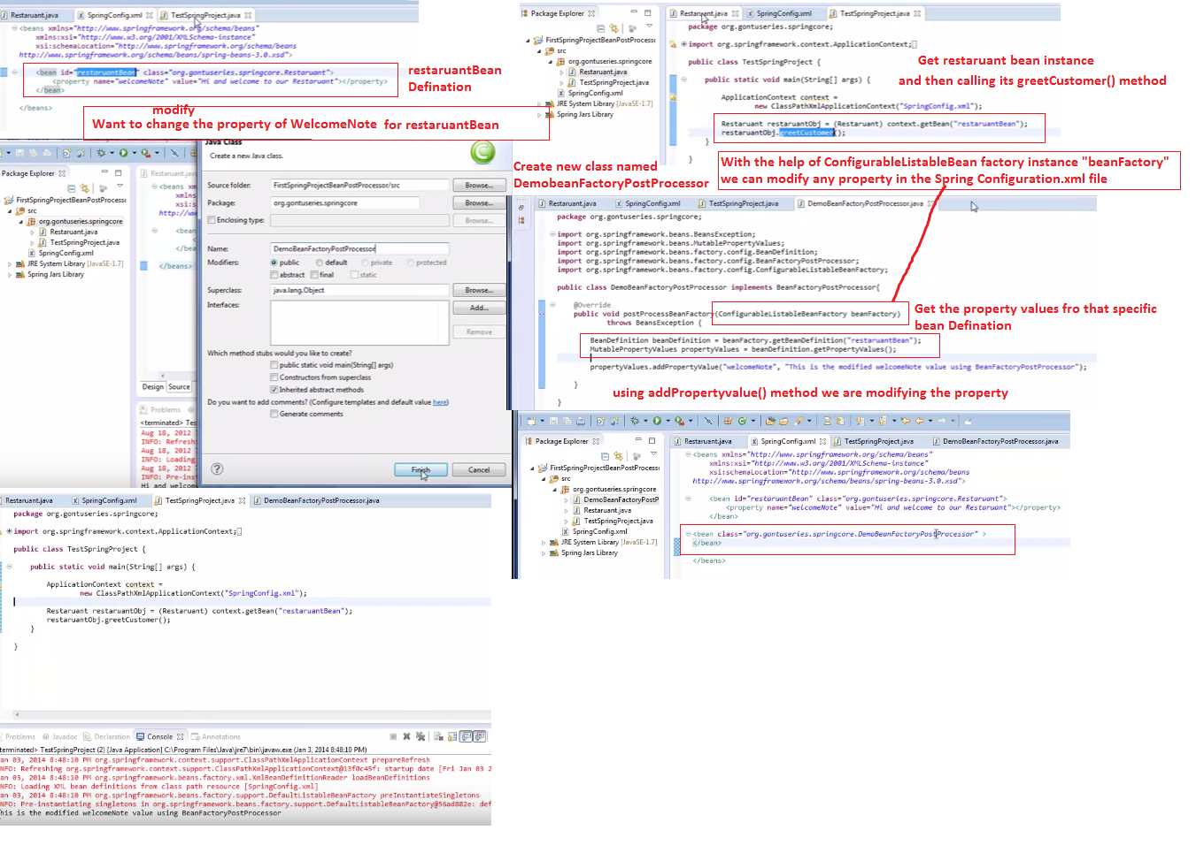

# Spring Tutorial 17 - A PropertyPlaceHolderConfigurer concept in spring framework

